“Ted Trips” Wire-frames

C.Lynskey, Ke Jia Wen, B.Harkin



TED TRIPS WEBSITE WIREFRAMES

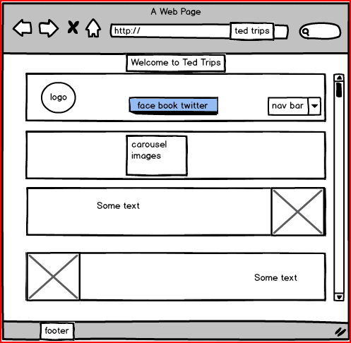

**1: TED TRIPS “HOME” PAGE**

**The Ted Trips home page will have the header containing the site logo, and name. The navigation will be set out to the left hand side. There will be a background image/pattern and a carousel of images. Located top right are the social media links and to the right is a scroll bar. The footer will contain site copyright information .This page is accessible through any page on the site.**

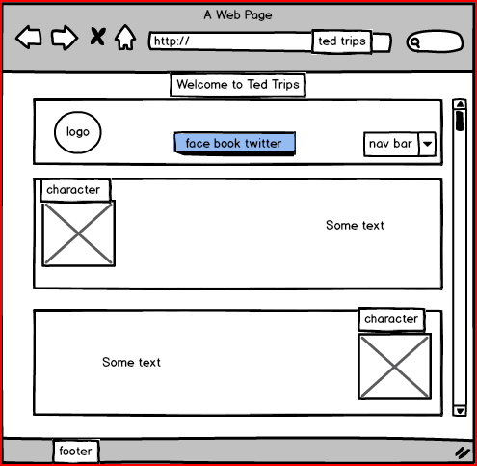

2: **TED TRIPS “characters” PAGE**

**The first of 2 character pages each contains the header footer and navigation panels and a scroll bar to the right hand side as seen in the home page. There will be a short character bio for two characters per page with link to main trip page and booking. This page is accessible through any page on the site.**



**3: TED TRIPS “character” PAGE**

**The second of 2 character pages each contains the header footer and navigation panels and a scroll bar to the right hand side. There will be a short character bio for two characters per page with link to main trip page and booking. This page is accessible through any page on the site.**

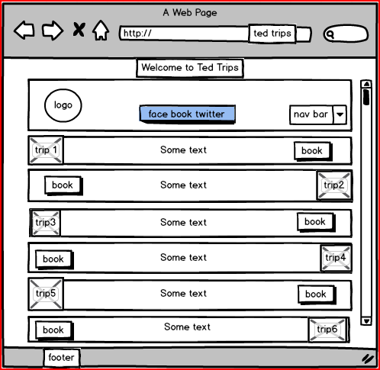

**4. TED TRIPS “TRIPS” PAGE**

**The Ted trips page again contains the header, footer, a scroll bar and navigation panels as seen in the home page description. There will be an image of the character involved in the specific trip and a description next to that. This page is accessible through any page on the site. Each trip container has a “book “ button linking to the booking page and the images provide access to venues sites for booking.**

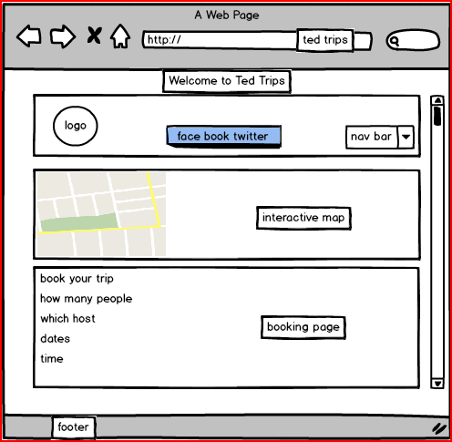

**5: TED TRIPS “BOOKING” PAGE**

**The booking page contains the header, footer, a scroll bar and navigation panels as seen in the home page description. There are a list of trips where the user can indicate a trip to book, a time and date selection section and an interactive map The booking page is accessible from any page on the site. The venues are booked separately where applicable with the “ted experience” being booked from this page.**

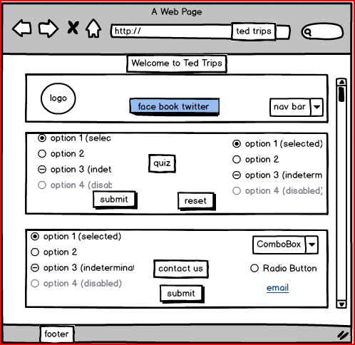

6: TED TRIPS “QUIZ/CONTACT” US PAGE

This page contains an interactive father Ted quiz. Asking for Ted related questions and giving correct answers and final score. It also contains a contact us form and further contact information. **This page is accessible through all others on the site.**

